**Practical ___**

**Writeup:**

**Practical ___**

**Aim:**

**Description:**

**User interface Diagram:**

**Code:**

**Bot.py:**

import aiml

import tkinter as tk

class CollegeEnquiryChatBot:

def __init__(self, master):

self.master = master

master.title("College ChatBot")

# Chat history display

self.chatbox = tk.Text(master, state='disabled', wrap='word', height=10, width=60)

self.chatbox.grid(row=0, column=0, columnspan=4, padx=30, pady=30)

# User input entry field

self.user_input_entry = tk.Entry(master, width=70)

self.user_input_entry.grid(row=2, column=0, padx=30, pady=30)

# Send button

self.send_button = tk.Button(master, text="ok", command=self.process_user_input)

self.send_button.grid(row=2, column=2, padx=30, pady=30)

# AIML kernel initialization

self.kernel = aiml.Kernel()

self.kernel.learn("bot.aiml")

self.kernel.respond("Loading College ChatBot")

# Initial welcome message

self.update_chatbox("Chat: Hello! I'm your College ChatBot,Created By Muskan. How can I help you today?")

def process_user_input(self):

user_input = self.user_input_entry.get()

self.update_chatbox(f"Human: {user_input}")

if user_input.lower() == "end":

self.update_chatbox("Chat: Goodbye!")

self.master.destroy()

else:

bot_response = self.kernel.respond(user_input)

self.update_chatbox(f"Chat: {bot_response}")

self.user_input_entry.delete(0, 'end') # Clear the entry field

def update_chatbox(self, message):

self.chatbox.config(state='normal')

self.chatbox.insert(tk.END, message + "\n")

self.chatbox.see(tk.END)

self.chatbox.config(state='disabled')

# Create the main application window

root = tk.Tk()

app = CollegeChatBot(root)

# Start the main loop

root.mainloop()

**Bot.aiml:**

<aiml>

<category>

<pattern>HI</pattern>

<template>HELLO I'M COLLEGE ENQUIRY CHATBOT CREATED BY MUSKAN.HOW CAN I HELP YOU?</template>

</category>

<category>

<pattern>IS ATTENDANCE CONMPULSORY FOR VALIA</pattern>

<template>Regular attendance is an essential criterion of academic achievement</template>

</category>

<category>

<pattern>WHO IS THE OWNER OF VALIA COLLEGE</pattern>

<template>Valia College is an education institute, established in 1961, run by Cosmopolitan Education Society located at D.N. Nagar, in Andheri West, Mumbai. The college is affiliated with University of Mumbai and accredited by NAAC.</template>

</category>

<category>

<pattern>CUT OFF OF LAST YEAR 2022 OF BSCIT</pattern>

<template>35%</template>

</category>

<category>

<pattern>CUT OFF OF LAST YEAR 2022 OF BMS</pattern>

<template>35%</template>

</category>

<category>

<pattern>WHAT IS THE LINK FOR ADMISSION</pattern>

<template>https://valiacollege.co.in/link-for-admission/</template>

</category>

<category>

<pattern>WHAT ARE THE SUBJECTS OFFERED IN VALIA COLLEGE</pattern>

<template>The various undergraduate programs offered are Bachelor of Commerce, Bachelor of Commerce (Accounting and Finance), Bachelor of Management Studies, Bachelor of Arts in Multimedia and Mass Communication, Bachelor of Science (Information Technology). The college also offers two masters programs Master of Commerce (Advanced Accountancy) and Master of Science (Information Technology). The Bachelor of Commerce program is in the grant in aid system and all other programs are self -financed.</template>

</category>

<category>

<pattern>WHO IS THE PRINCIPAL OF VALIA COLLEGE</pattern>

<template>Dr. Shobha A. Menon Principal, Dr. Shobha A. Menon, is recognised as a Teacher of the University of Mumbai for the Ph. D.</template>

</category>

<category>

<pattern>HOW CAN I GET ADMISSION IN VALIA COLLEGE</pattern>

<template>All admissions for in-house students are given across the counter and no separate list will be displayed. Students who fail to take direct admissions during the stipulated time by submitting hard copies of filled admissions forms in the college office will not be considered for admissions later.</template>

</category>

<category>

<pattern>IS VALIA COLLEGE UNDER MUMBAI UNIVERSITY</pattern>

<template>The college is affiliated with University of Mumbai and accredited by NAAC.</template>

</category>

<category>

<pattern>HOW MUCH IS THE INTAKE ACROSS ALL COURSES BEING OFFERED AT VALIA COLLEGE OF ARTS AND COMMERCE</pattern>

<template>Overall seats across various courses at Valia College of Arts and Commerce goes up to 920. Valia College of Arts and Commerce offers Degree courses including 5 UG and 2 PG courses. These programs are offered in Full Time mode.</template>

</category>

<category>

<pattern>IS THERE ANY SOCIAL MEDIA ACCOUNT OF VALIA COLLEGE</pattern>

<template>No</template>

</category>

<category>

<pattern>DOES VALIA COLLEGE PROVIDE GOOD PLACEMENT FACILITIES</pattern>

<template>Valia College of Arts and Commerce has been rated 3.2 on placements.</template>

</category>

<category>

<pattern>WHAT FACILITIES ARE THERE AT VALIA COLLEGE IN TERMS OF INFRASTRUCTURE</pattern>

<template>Valia College of Arts and Commerce has been rated 3.5 on Infrastructure parameter. Valia College of Arts and Commerce provides good facilities all around the campus such as Auditorium, Cafeteria, Gym, Labs, Library, Sports Complex. Valia College of Arts and Commerce has also been rated 3.6 for Campuslife.</template>

</category>

<category>

<pattern>DOES VALIA COLLEGE HAVE GOOD AND EXPERIENCED FACULTY</pattern>

<template>Valia College of Arts and Commerce has been rated 3.9 for faculty as per reviews by students. This shows that Institute has qualified and experienced faculty members.</template>

</category>

<category>

<pattern>WHAT ARE THE SUBJECT IN MSCIT PART1 SEM1</pattern>

<template>Research in Computing, Data Science, Cloud Computing, Soft Computing Technique.</template>

</category>

<category>

<pattern>WHAT ARE THE SUBJECT IN MSCIT PART1 SEM2</pattern>

<template>Big Data Analytics, Modern Networking, Microservices Architecture, Image Processing</template>

</category>

<category>

<pattern>WHAT ARE THE SUBJECT IN FYBCOM SEM1</pattern>

<template>Environment and Management of Financial Services Principles of Management Business Economics - I Business Communication - I Quantitative Methods - I Financial Accounting - I Foundation Course - I</template>

</category>

<category>

<pattern>WHAT ARE THE SUBJECT IN FYBCOM SEM1</pattern>

<template>Business Law, Quantitative Methods - II, Financial Accounting - II, Business Communication - II, Organizational Behavior, Principles and Practices of Banking and Insurance, Foundation Course - II'</template>

</category>

<category>

<pattern>WHAT ARE THE SUBJECT IN FYBMS SEM1</pattern>

<template>Introduction to Financial Accounts, Business Law, Business Statistics, Business Communication - I, Foundation Course - I, Foundation of Human Skills, Business Economics - I</template>

</category>

<category>

<pattern>WHAT ARE THE SUBJECT IN FYBMS SEM2</pattern>

<template>Principles of Management, Principles of Marketing, Industrial Law, Business Communication - II, Business Mathematics, Business Environment, Foundation Course - II</template>

</category>

<category>

<pattern>WHAT ARE THE SUBJECT IN MCOM PART1 SEM1</pattern>

<template>Strategic Management, Economics for Business Decisions, Cost and Management Accounting, Business Ethics and Corporate Social Responsibility</template>

</category>

</aiml>

**Output:**

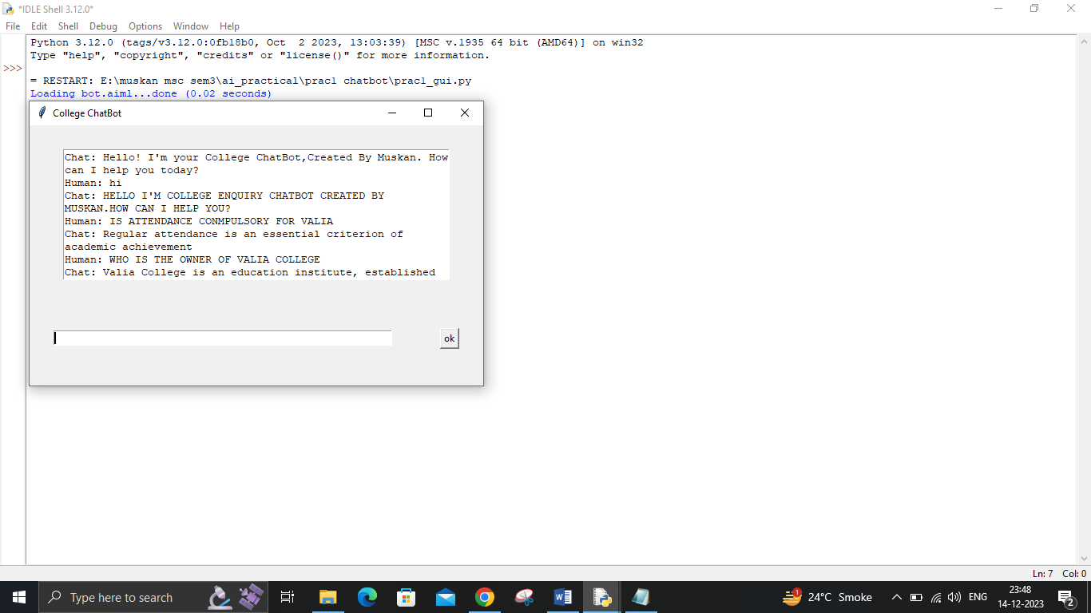

**Practical ___**

**Writeup:**

**Practical ___**

**Aim:**

**Description:**

**Code:**

# calculate the probability of cancer patient and diagnostic test

# calculate P(A|B) given P(A), P(B|A), P(B|not A)

def bayes_theorem(p_a, p_b_given_a, p_b_given_not_a):

# calculate P(not A)

not_a = 1 - p_a

# calculate P(B)

p_b = p_b_given_a * p_a + p_b_given_not_a * not_a

# calculate P(A|B)

p_a_given_b = (p_b_given_a * p_a) / p_b

return p_a_given_b

# P(A)

p_a = 0.0002

# P(B|A)

p_b_given_a = 0.85

# P(B|not A)

p_b_given_not_a = 0.05

# calculate P(A|B)

result = bayes_theorem(p_a, p_b_given_a, p_b_given_not_a)

# summarize

print('P(A|B) = %.3f%%' % (result * 100))

print("___________done by Muskan Momin__")

**Output:**

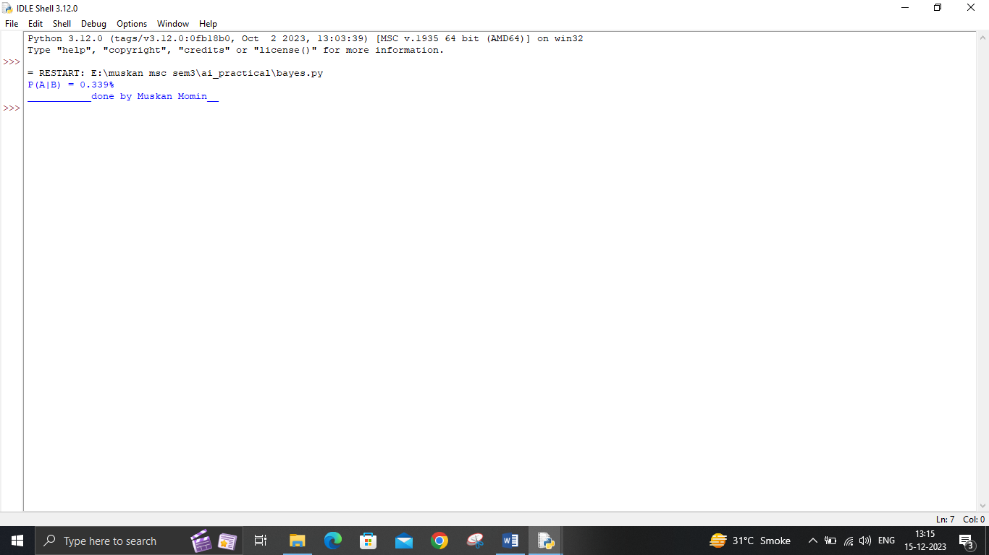

**Practical ___**

**Writeup:**

**Practical ___**

**Aim:**

**Description:**

**Code:**

**conditional.py:**

def conditional():

crime_stats = 0.20

crime_basicWStats = 0.50

crime_basicWOStats = 0.50

prob_both = crime_stats * crime_basicWStats

print("Probability that criminal committed both is",round(prob_both,3))

prob_basic = (prob_both) + ((1-crime_stats)*crime_basicWOStats)

print("Probability that criminal committed only basic crime is",round(prob_basic,3))

stats_given_basic = prob_both/prob_basic

print("Conditional Probability is",round(stats_given_basic,3))

print("Muskan")

conditional()

**Output:**

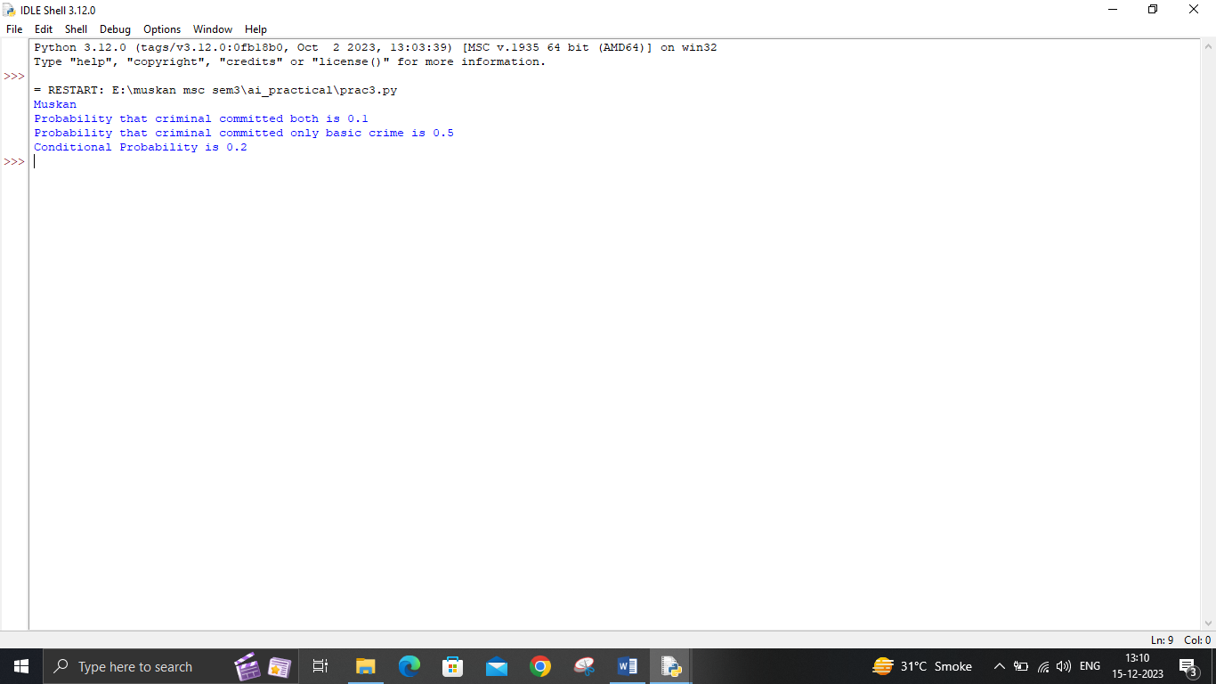

**Code:**

**joint.py**

import pandas as pd

import numpy as np

# Generate a hypothetical dataset

data = {

'Table_A': np.random.choice(['M', 'N', 'O'], size=100),

'Table_B': np.random.choice(['T', 'U', 'V'], size=100),

}

df = pd.DataFrame(data)

# Display the dataset

print("Generated Dataset:")

print(df.head(), "\n")

# Function to calculate joint probabilities

def joint_probs(DF, index, cols):

all_cols = index + cols

N = DF.shape[0]

joint_counts = pd.pivot_table(DF[all_cols], index=index, columns=cols, aggfunc='size').replace(np.nan, 0)

joint_prob = np.round(joint_counts / N, 3)

return joint_prob

# Calculate joint probabilities for the hypothetical dataset

JP_hypothetical = joint_probs(df, ['Table_A'], ['Table_B'])

print("Joint Probabilities:")

print(JP_hypothetical)

print("Muskan")

**Output:**

